Project Design Phase-II
Technology Stack (Architecture & Stack)

Date | 08 October 2026
Team ID
Project Name | Auto Ticket Classification using ServiceNow Flow Designer
Maximum Marks | 4 Marks

Technical Architecture:
The Deliverable shall include the architectural diagram as below and the information as per the table1 & table 2
Architecture: Auto ticket classification for the school IT helpdesk
Reference: ServiceNow Flow Designer, Table and Update Set documentation (docs.servicenow.com)
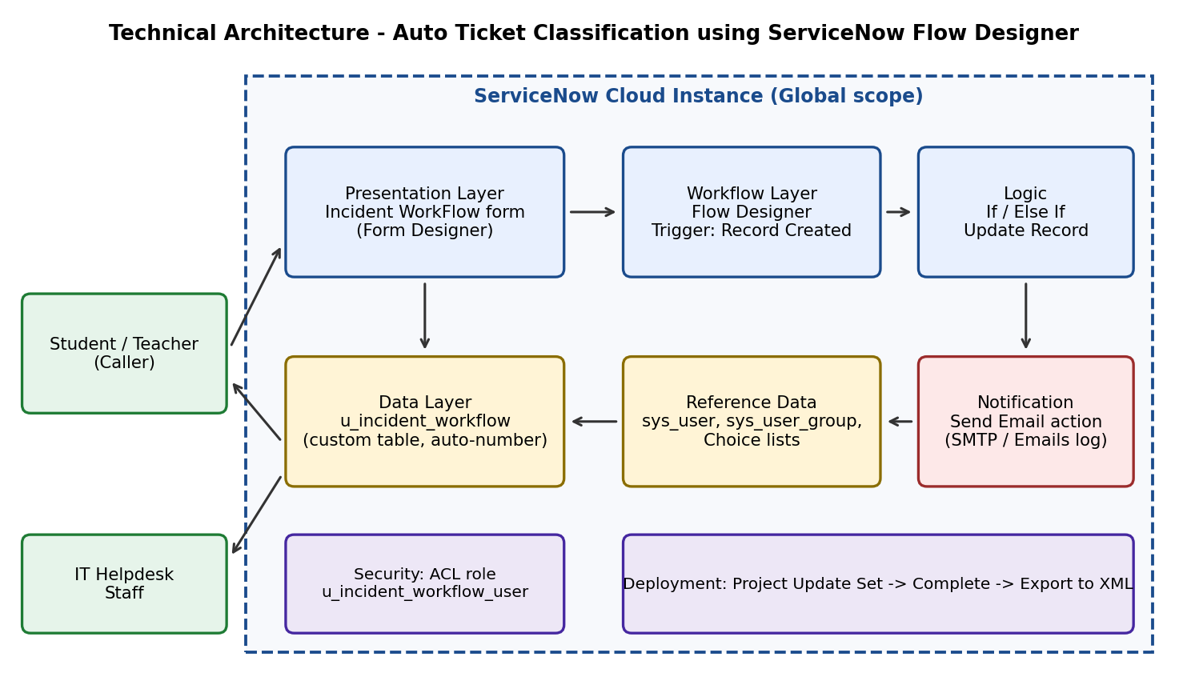

Table-1 : Components & Technologies:
S.No | Component | Description | Technology
- 1 | User Interface | Incident WorkFlow form where the caller enters Caller and Short Description; form laid out in Form Designer | ServiceNow platform UI, Form Designer
- 2 | Application Logic-1 | Automatic classification: If / Else If keyword checks on Short Description, then Update Record sets Category and Subcategory | ServiceNow Flow Designer (no-code)
- 3 | Application Logic-2 | Dependent choice logic: Subcategory choices depend on Category using backend dependent values (e.g. Wi-Fi -> network) | Dictionary 'Use dependent field' configuration
- 4 | Application Logic-3 | Confirmation email to the caller using the Caller > Email data pill | Flow Designer 'Send Email' action
- 5 | Database | Custom table u_incident_workflow with auto-number (prefix INC, starts at 500, 5 digits) and fields for caller, category, subcategory, descriptions, state, group and assignee | ServiceNow relational database (platform managed)
- 6 | Cloud Database | Database hosted as part of the ServiceNow cloud instance | ServiceNow cloud instance
- 7 | File Storage | Exported update set (XML, about 182 KB) kept for sharing by email or another approved method | Local file system
- 8 | External API-1 | Outbound email delivery for the notification; sent mails are logged in System Logs > Emails | SMTP (ServiceNow email service)
- 9 | External API-2 | Not used in this version; users and groups come from the internal sys_user and sys_user_group tables | Not applicable
- 10 | Machine Learning Model | Not used in this version; listed as a possible future addition | Predictive Intelligence (future scope)
- 11 | Infrastructure (Server / Cloud) | Application deployed on a ServiceNow cloud instance in Global scope; moved between instances through the update set  Local Server Configuration: not required  Cloud Server Configuration: ServiceNow instance | ServiceNow Cloud, Update Set

Table-2: Application Characteristics:
S.No | Characteristics | Description | Technology
- 1 | Open-Source Frameworks | No open-source framework is used; the solution is built with the ServiceNow low-code / no-code tools | ServiceNow Flow Designer, Form Designer
- 2 | Security Implementations | Access controls (ACLs) created with the table and the role u_incident_workflow_user; changes controlled through a separate update set | ServiceNow ACLs, role-based access
- 3 | Scalable Architecture | Keyword rules can be extended with extra Else If branches and choice values, and the platform handles growth in ticket records | Flow Designer, ServiceNow cloud platform
- 4 | Availability | Hosted on the ServiceNow cloud instance, so the form and the flow are available whenever the instance is up | ServiceNow cloud instance
- 5 | Performance | Flow triggers once on record creation and only if Category is empty, avoiding repeated processing; uses simple Contains checks | Flow Designer trigger condition

References:
https://docs.servicenow.com/
https://www.servicenow.com/products/workflow-automation.html
https://c4model.com/

